Functional Specifications for Community Logistics Management Information System (LMIS) database application:



Prepared by Randy Wilson, Integrated Health Systems Strengthening Project (IHSSP) and the Strengthening Pharmaceutical System (SPS) project team

With financing from USAID

DRAFT 1: December 4, 2010

Contents

Context and Purpose 2

Purpose of the Community LMIS database: 2

System Users: 2

Process Flow Diagram: 3

System Inputs 4

System Outputs 4

Process 4

Operating Environment: 5

Client software: 5

Server software: 5

Functional Specifications for Community Logistics Management Information System (LMIS) database application:

# Context and Purpose

Rwanda’s community health worker (CHW) program has been scaled up dramatically in recent years. At this time, Rwanda has 59,348 CHWs or approximately 4 per village (a Maternal Health Promoter and an In-charge of Social Affairs were added in 2008). They receive training that corresponds with their primary tasks, which include:

* Community Integrated Management of Childhood Illness (IMCI);
* Community Based Maternal and Newborn Health care(C-MNH);
* Case finding for suspected TB, polio and other epidemic disease
* Home-based treatment of HIV, Opportunistic Infections and TB.
* Behavior Change Communication “BCC”
* Service delivery data management ”Community HIS”

In order for these CHWs to provide uninterrupted care to their communities, it is essential to have access to the essential drugs and supplies these health workers dispense.

The current distribution system is primarily a pull system as described in the process flow diagram on the following page. Because of limited numeracy of CHWs, the Health Center-based CHW supervisors manage most of the stock resupply process for health workers, topping up their stocks during monthly visits that the CHWs make to the HC and during supervisory visits to the villages where the CHWs work.

# Purpose of the Community LMIS database:

Rwanda is in the process of developing a comprehensive LMIS system that will cover all levels of health system. That system is planned to begin operating in mid-2011 – however it is uncertain if it will include the large CHW distribution channel during the initial phase. During the interim period data are required from each CHW cooperative in order to ensure adequate supply of essential drugs and supplies.

# System Users:

The primary users of this system will be staff in the District Pharmacies and from the Pharmacy Task Force (PTF) at the central level. There will be 3 classes of users:

1. Read only users – can run reports and view requisitions, but can’t change any data
2. Data entry users – can enter and edit requisitions and run reports, but can’t change configuration options
3. Administrators – can configure the system, enter, edit and delete requisitions and run any of the analysis reports.

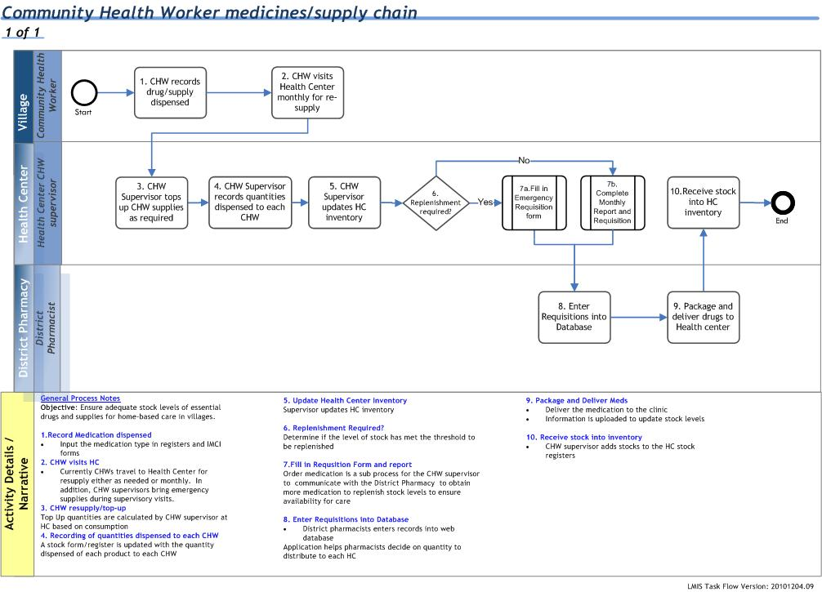

# System Inputs

The system has two levels of inputs:

* Semi-permanent data about district pharmacies, health centers (CHW cooperatives) that serve as distribution points for CHW supply
* Emergency requisition forms (same forms used for Monthly and Emergency requisitions: See Annex 1, 2, 3 and 4)
* Monthly report and requisition forms

# System Outputs

At the current time the primary outputs of the system include:

* A dashboard indicating the proportion of CHW cooperatives reporting using each of the formats during each reporting period.
* A printable copy of:
  + any of the individual requisition forms entered
  + a delivery note for health centers
* A variety of listing reports used for estimating stock levels and consumption:
  + Consolidated consumption and stock report – by district, national level
  + List of cooperatives reporting and missing reports
  + Lists of stock items that are likely to be over-stocked
  + Lists of stock items that are out of stock or in danger of rupture

In addition, special queries will be developed that will enable users to access the data through Excel pivot tables and charts for ad hoc analysis

# Process

The process flow diagram, above, describes the entire CHW supply chain. This system will be used primarily to support steps 8 and 9 of this supply chain. The following are the key functions that the system must support:

1. Configuration:
   1. Set up and update CHW cooperative/HC data – interoperable with the national health facility register
   2. Set up and manage stock items – interoperable with the national drug registry
   3. Set up reporting and requisition formats
2. Report/requisition data entry
   1. Add new requisition
   2. Edit existing requisition
   3. Delete requisition (administrator only)
3. Prepare delivery notes:
   1. Adjust quantities to be distributed
   2. Print distribution report
4. Printing report:
   1. Reporting compliance report
   2. Quarterly/Monthly stock and consumption report
5. Maintenance functions:
   1. Backup data
   2. Export data to Excel for pivot table and chart analysis

At the current time the system will not be used to manage stock levels of each drug (receiving stock, making stock adjustments, order processing from CAMERWA) at the district pharmacies, only to process reports and prepare delivery notes. In addition, there will be no attempt made to track stock or consumption at the individual CHW level.

# Operating Environment:

The Community LMIS is designed to work in a decentralized environment. Data are to be entered at the lowest level possible, either Health Center or District Pharmacy depending upon the availability of computer equipment and internet connectivity. When computers are not available, paper forms will be completed and entered by staff at the next level of the hierarchy (District Pharmacy or Pharmacy Task Force).

## Client software:

The client software should operate without specialized software installed on the client computer apart from one of the following browsers: Firefox, Internet Explorer, Safari or Chrome.

## Server software:

The system should conform to Rwanda’s enterprise architecture standards. These include:

* Use of open source for software development when practical. Development tools including PHP and Ruby on Rails are in use.
* The database should be server-based, secure database such as MySQL, POSTGRESS or MS SQL server 2008.